**Implementation details:**

1 The project is implemented in C language.

2 An event-driven (select function) architecture is used to keep a list of active connections and loop over them, performing a little bit of work on behalf of each connection.

3 There is a forever loop on select function:

Accept new connection from incoming client

Parse HTTP request

Ensure well-formed request (return error otherwise)

Determine if target file exists and if permissions are set properly (return error otherwise)

Transmit contents of file to the client

Close the connection

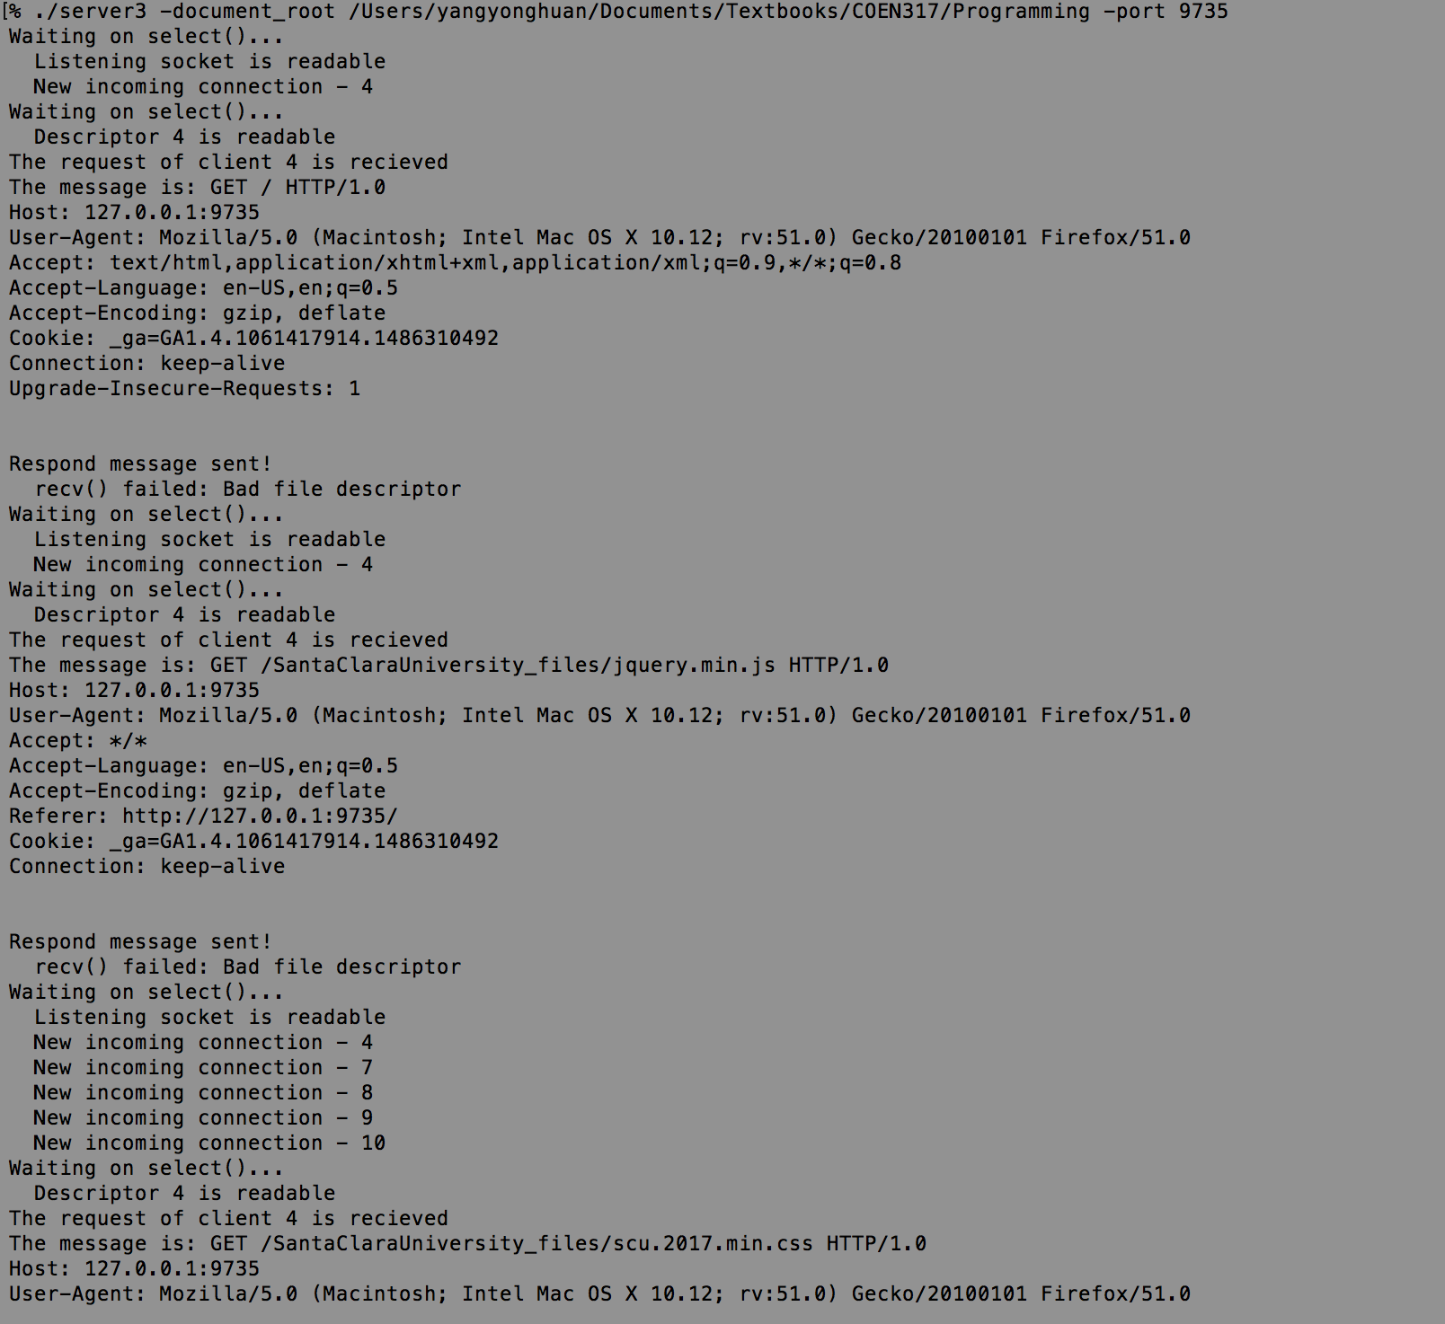

**Request making for the client:**

1 telnet to the server:

telnet 127.0.0.1 9735

2 send request:

GET / HTTP/1.0

3 receive the files

**Supported file types:**

In this project, the server **supported .html, .jpg, .gif, .png, .jpeg, .txt, .ico** content types.

Html:

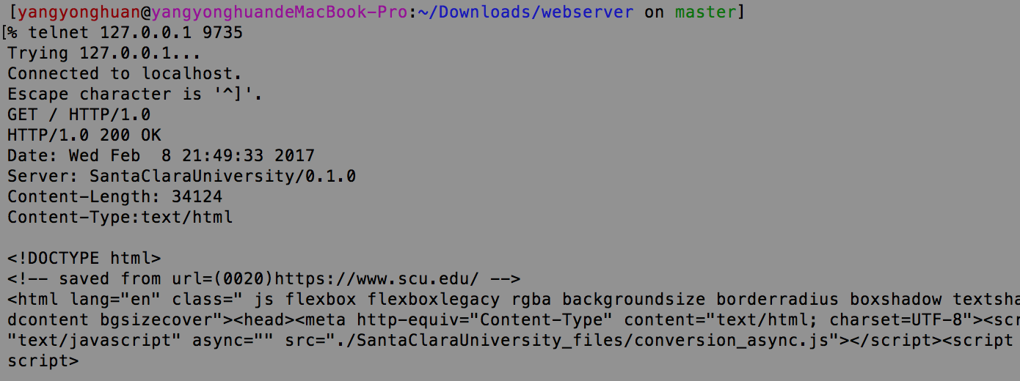



jpg:

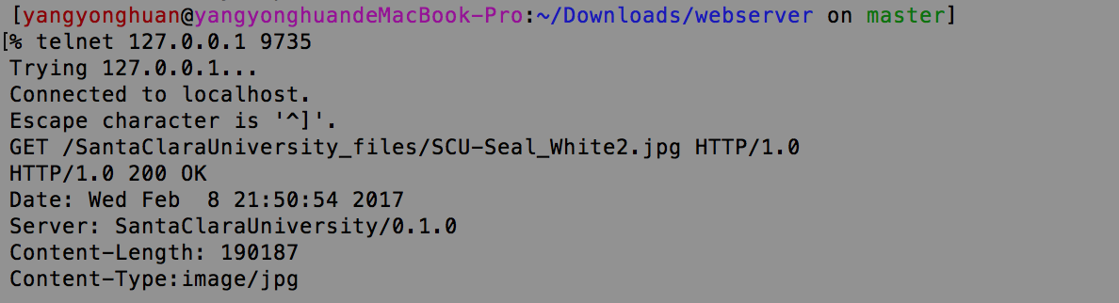



**Status Code:**

200 OK:

If the requested file exists and the client has the permission, there will be a header sent back. The header includes:

Code: HTTP/1.0 200 OK

Date:

Server name:

Content-Length:

Content-type:



403 Forbidden:

The request was a valid request, but the client does not have the necessary permissions for the resource.

File: /SantaClaraUniversity_files/footer-mission.png

Change the permissions of the file to 700, other users not in the group do not have the read access permission.

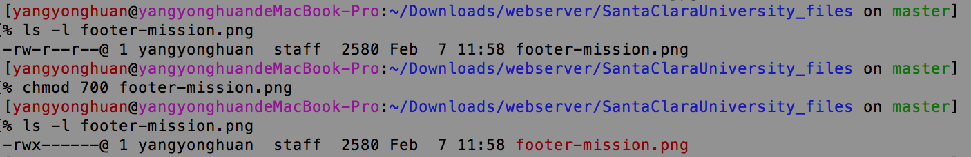

When the client want retrieve this file, the server returns “403 Forbidden” Code!

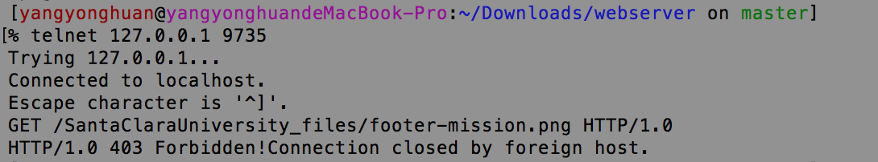

This is the response for the browser.

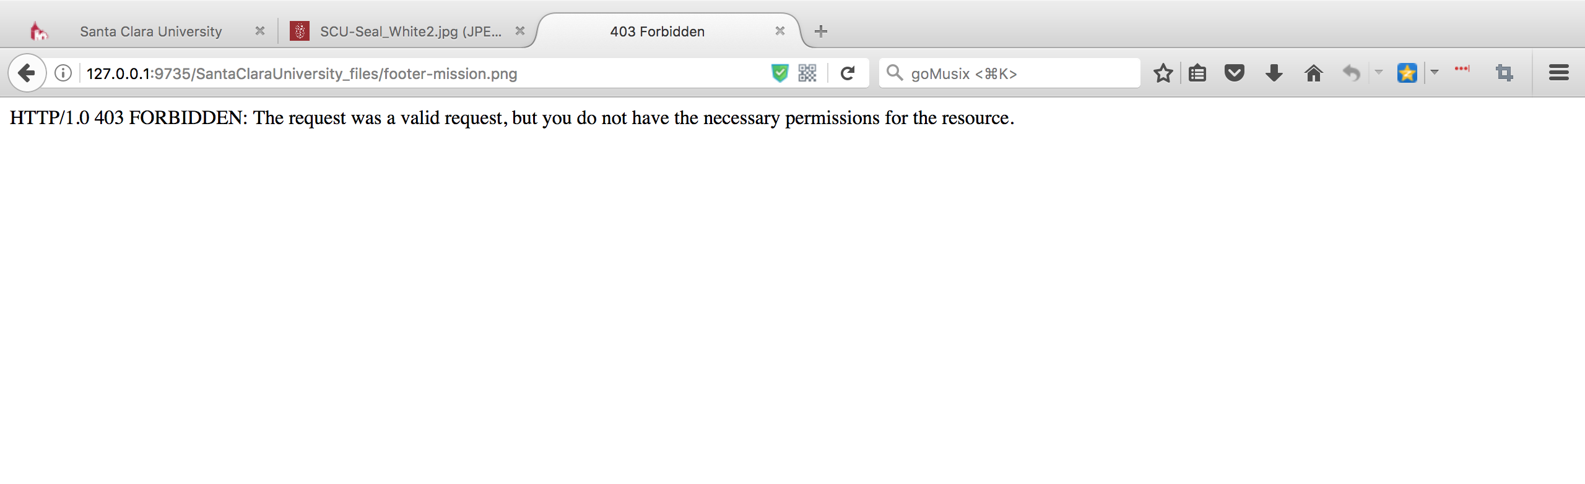

400 Bad Request:

Here are some examples for “400 Bad Request” code:

Request “”;

Wrong format of the request command;

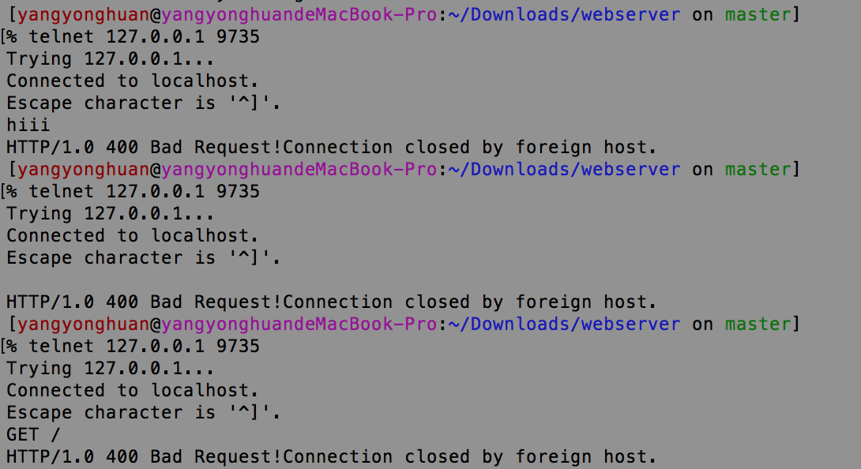

404 Not Found:

The server could not fulfill the request because the resource does not exist.

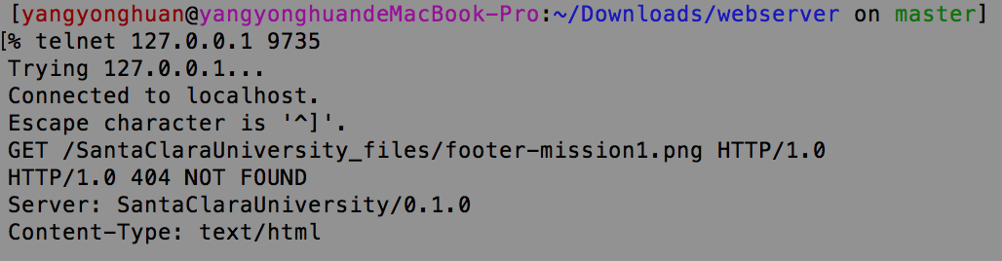

This is the response for the browser.

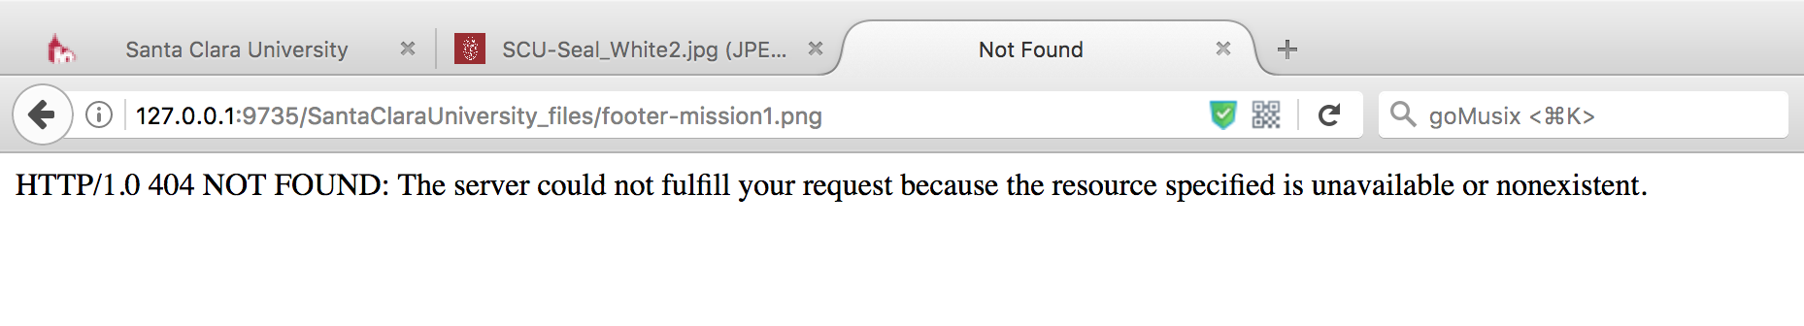

**Firefox as a client:**

The project support HTTP/1.0 protocol to allow Firefox to connect to this web server and retrieve the content of the Santa Clara University home page.

After copying the appropriate files to the server’s document directory, an appropriate page will pop out as below.

Type 127.0.0.1:9735 in the address field:









